**E115 – Programming and Data Analysis**

**Practice questions for Week 01**

**If… ElseIf… Else… End If**

1. Based on the code below, which of the following sets of conditions will result in the variable “TakeCab” being False?

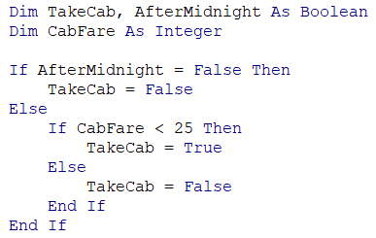

1. AfterMidnight = True, CabFare = 25
2. AfterMidnight = False, CabFare = 10
3. AfterMidnight = True, CabFare = 30
4. i and ii
5. i and iii
6. ii and iii
7. i, ii and iii
8. Write a subroutine named “BMI” that will calculate the body-mass index (BMI) based on the height and weight that is in Cells A2 and B2, and display a message box.

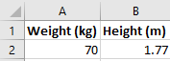

The message should read “Overweight” if the BMI is more than 25.

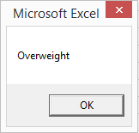

The message should read “Underweight” if the BMI is less than 18.

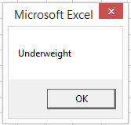

The message should read “Normal” for all other cases.

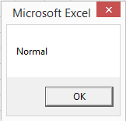

The formula to calculate BMI is

BMI = $\frac{Weight}{Height×Height}$

1. Write a subroutine named “LOA” that will display a message box.

The message should read “Absent without LOA” if the value in Cell A2 is “X” and the value in Cell B2 is “No”.

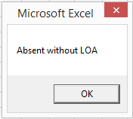 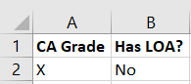

The message should read “Absent with LOA” if the value in Cell A2 is “X” and the value in Cell B2 is “Yes”.

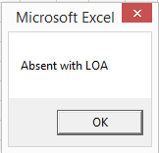 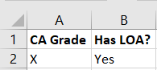

The message should read “Present” if the value in Cell A2 is any value other than “X”.

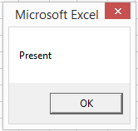 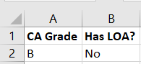

1. Write a macro that will display the following message box if the values keyed into Cells A2 and B2 meets the RP Bursary criteria (given below).

